Yash Manoj Kulkarni - E5685312 - Airline Schema:
select * from air_credit_card_details;
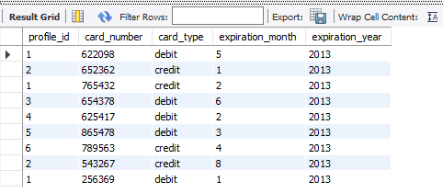
select * from air_passenger_profile;
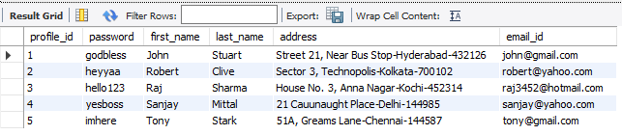
select * from air_ticket_info;
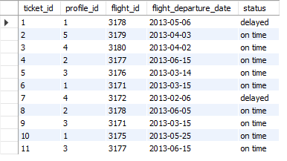
select * from air_flight_details;
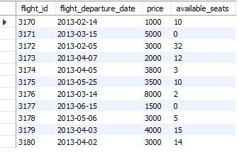
select * from air_flight;
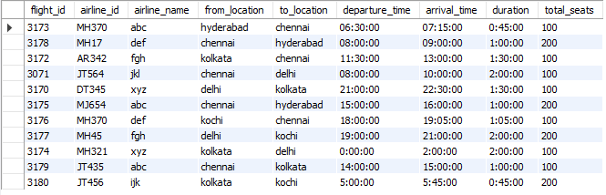
___________________________________________________________________________
-- 1. Write a query to display the average monthly ticket cost for each flight in ABC Airlines. The query should display the Flight_Id,From_location,To_Location,Month Name as “Month_Name” and average price as “Average_Price”. Display the records sorted in ascending order based on flight id and then by Month Name.
SELECT f.flight_id,
f.from_location,
f.to_location,
fp.Month_Name,
fp.Average_Price
FROM air_flight f,
(
SELECT flight_id,
MONTHNAME(flight_departure_date) AS Month_Name,
AVG(price) as Average_Price
FROM air_flight_details
GROUP BY flight_id,
MONTHNAME(flight_departure_date)
) fp
WHERE f.flight_id = fp.flight_id
and f.airline_name = 'ABC AIRLINES'
order by f.flight_id, fp.Month_Name;
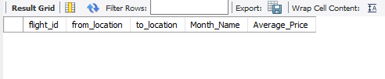
-- 2. Write a query to display the number of flight services between locations in a month. The Query should display From_Location, To_Location, Month as “Month_Name” and number of flight services as “No_of_Services”. Hint: The Number of Services can be calculated from the number of scheduled departure dates of a flight. The records should be displayed in ascending order based on From_Location and then by To_Location and then by month name.
SELECT f.from_location,
f.to_location,
s.Month_Name,
SUM(s.No_of_Services) AS No_of_Services
FROM air_flight f JOIN
(
SELECT flight_id,
MONTHNAME(flight_departure_date) AS Month_Name,
COUNT(flight_departure_date) AS No_of_Services
FROM air_flight_details
GROUP BY flight_id,
MONTHNAME(flight_departure_date)
) s
ON s.flight_id=f.flight_id
GROUP BY f.from_location,
f.to_Location,
s.Month_Name
order by f.from_location,
f.to_Location, s.Month_Name;
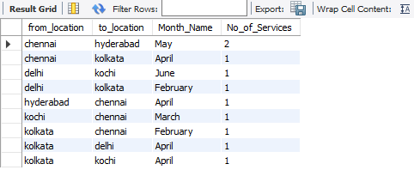
-- 3. Write a query to display the customer(s) who has/have booked least number of tickets in ABC Airlines. The Query should display profile_id, customer’s first_name, Address and Number of tickets booked as “No_of_Tickets”Display the records sorted in ascending order based on customer's first name.
SELECT cus.profile_id,
cus.first_name,
cus.address,
mintkt.No_of_Tickets
FROM air_passenger_profile cus,
(
SELECT MIN(s.Tot_No_of_Tickets) AS No_of_Tickets
FROM (
SELECT profile_id,
COUNT(ticket_id) AS Tot_No_of_Tickets
FROM air_ticket_info
GROUP BY profile_id
) s
) mintkt,
( SELECT profile_id,
COUNT(ticket_id) AS Tot_No_of_Tickets
FROM air_ticket_info
GROUP BY profile_id
) tottkt
WHERE mintkt.No_of_Tickets = tottkt.Tot_No_of_Tickets
AND cus.profile_id = tottkt.profile_id
order by cus.first_name;
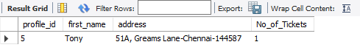
-- 4. Write a query to display flight id,from location, to location and ticket price of flights whose departure is in the month of april.Display the records sorted in ascending order based on flight id and then by from location.
SELECT fd.flight_id, af.FROM_LOCATION, af.TO_LOCATION, fd.price
FROM air_flight_details fd
join air_flight af on af.FLIGHT_ID=fd.FLIGHT_ID
where substring(fd.flight_departure_date,6,2)='04'
order by fd.flight_id, af.FROM_LOCATION;
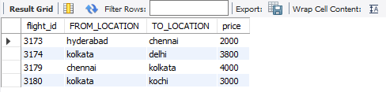
-- 5. Write a query to display the no of services offered by each flight and the total price of the services. The Query should display flight_id, number of services as “No_of_Services” and the cost as “Total_Price” in the same order. Order the result by Total Price in descending order and then by flight_id in descending order.Hint:The number of services can be calculated from the number of scheduled departure dates of the flight.
SELECT flight_id,
COUNT(flight_departure_date) AS No_of_Services,
SUM(price) AS Total_Price
FROM air_flight_details
GROUP BY flight_id order by total_price DESC, flight_id DESC;
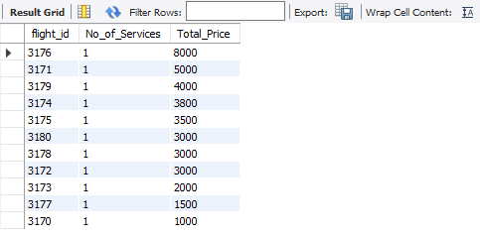
-- 6. Write a query to display profile id of passenger(s) who booked minimum number of tickets. In case of multiple records, display the records sorted in ascending order based on profile id.
SELECT profile_id FROM air_ticket_info
group by profile_id having count(profile_id)<=all(select count(profile_id)
from air_ticket_info
group by profile_id)
order by profile_id;
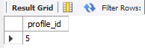
-- 7. Write a query to display unique profile id,first name , email id and contact number of passenger(s) who travelled on flight with id 3178. Display the records sorted in ascending order based on first name.
SELECT distinct ti.PROFILE_ID, pi.first_name, pi.email_id FROM air_ticket_info ti
join air_passenger_profile pi
on pi.profile_id=ti.profile_id
where flight_id=3148
order by pi.first_name;
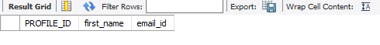
-- 8. Write a query to display the credit card type and no of credit cards used on the same type. Display the records sorted in ascending order based on credit card type.Hint: Use CARD_COUNT AS Alias name for no of cards.
SELECT c.card_type,
count(c.card_number) as 'CARD_COUNT'
FROM air_credit_card_details c
GROUP BY c.card_type;
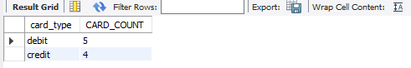
-- 9. Write a query to display the flights available in Morning, AfterNoon, Evening& Night. The Query should display the Flight_Id, From_Location, To_Location , Departure_Time, time of service as "Time_of_Service". Time of Service should be calculated as: From 05:00:01 Hrs to 12:00:00 Hrs - Morning, 12:00:01 to 18:00:00 Hrs -AfterNoon, 18:00:01 to 24:00:00 - Evening and 00:00:01 to 05:00:00 - NightDisplay the records sorted in ascending order based on flight id
SELECT f.flight_id,
f.from_location,
f.to_location,
f.departure_time,
CASE WHEN f.departure_time between '05:00:01' and '12:00:00' THEN 'Morning'
WHEN f.departure_time between '12:00:01' and '18:00:00' THEN 'Afternoon'
WHEN f.departure_time between '18:00:01' and '24:00:00' THEN 'Evening'
WHEN f.departure_time between '00:00:00' and '05:00:00' THEN 'Night'
END as 'Time_of_Service'
FROM air_flight f;
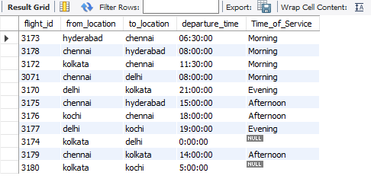
-- 10. Write a query to display the number of flights flying from each location. The Query should display the from location and the number of flights to other locations as “No_of_Flights”. Hint: Get the distinct from location and to location.Display the records sorted in ascending order based on from location.
SELECT from_location as 'Location',
count(flight_id) as 'No_of_Flights'
FROM air_flight
GROUP BY from_location;
